CaseManagement_CreationOfCase_Instance23_06-Aug-2018_03-28-52_AM_MouseClickActiononStaleElement.png

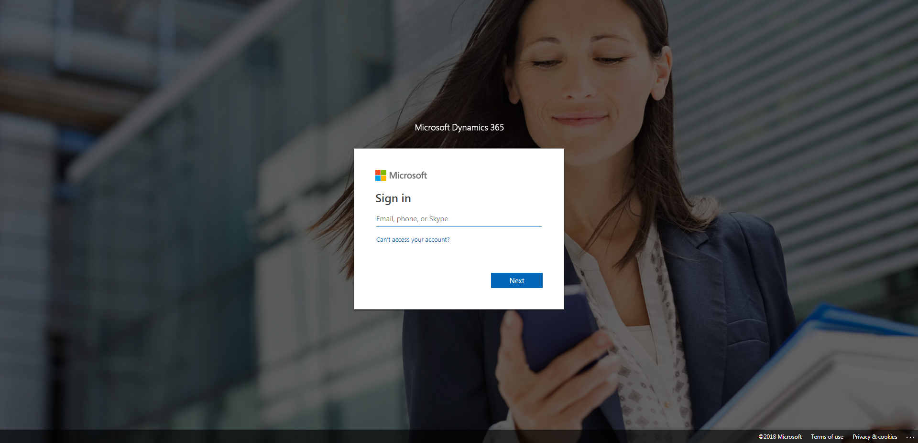

CaseManagement_CreationOfCase_Instance23_06-Aug-2018_03-29-16_AM_SingleSignOn.png

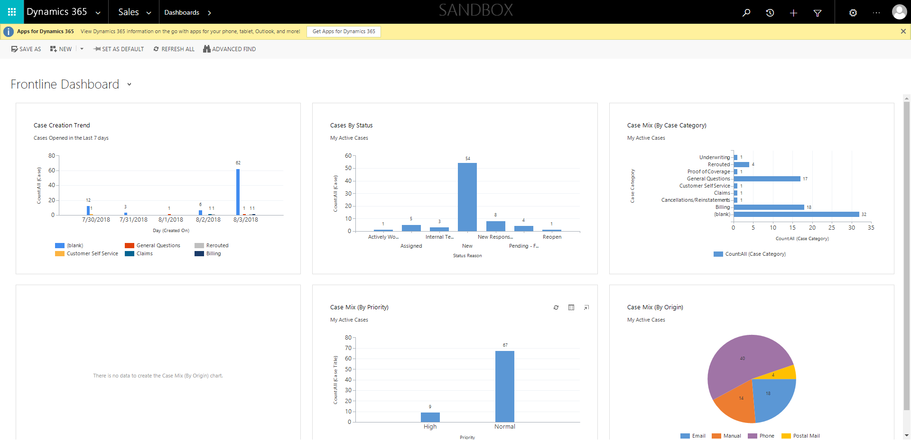

CaseManagement_CreationOfCase_Instance23_06-Aug-2018_03-29-13_AM_SingleSignOn.png

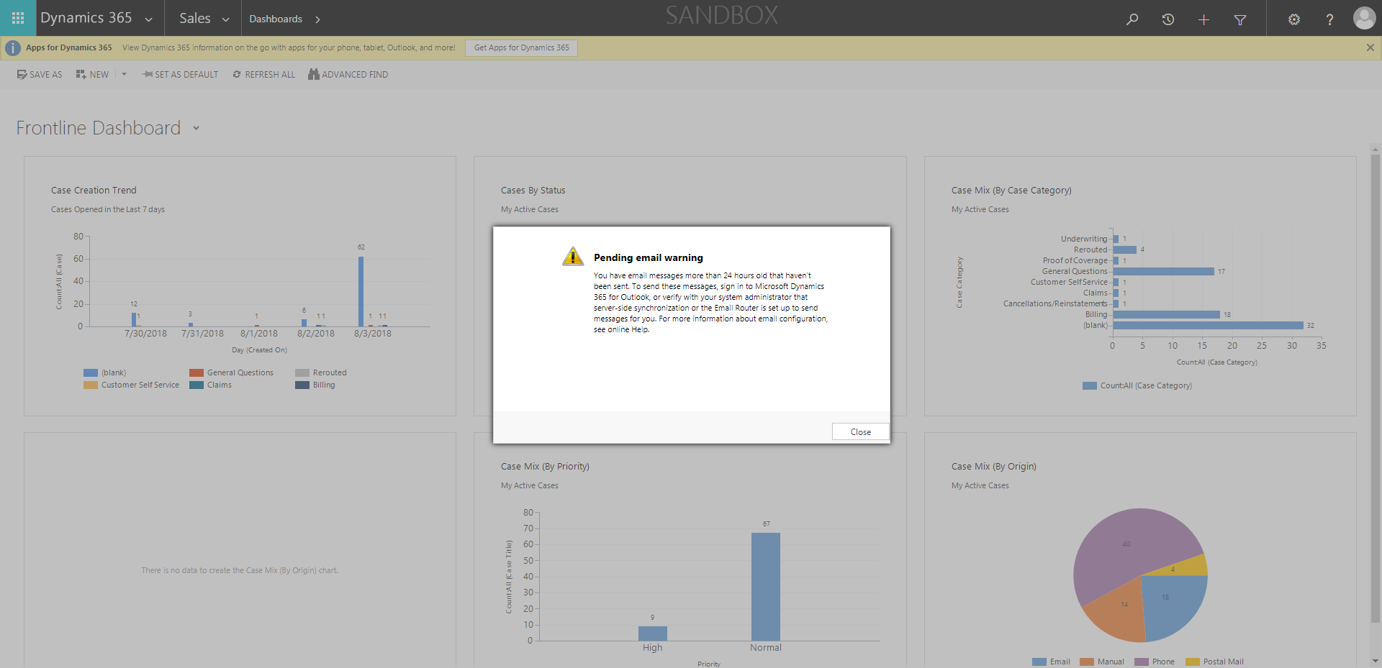

CaseManagement_CreationOfCase_Instance23_06-Aug-2018_03-29-21_AM_MouseClickActionMoveToElementByxpathimgaltServiceparentspan.png

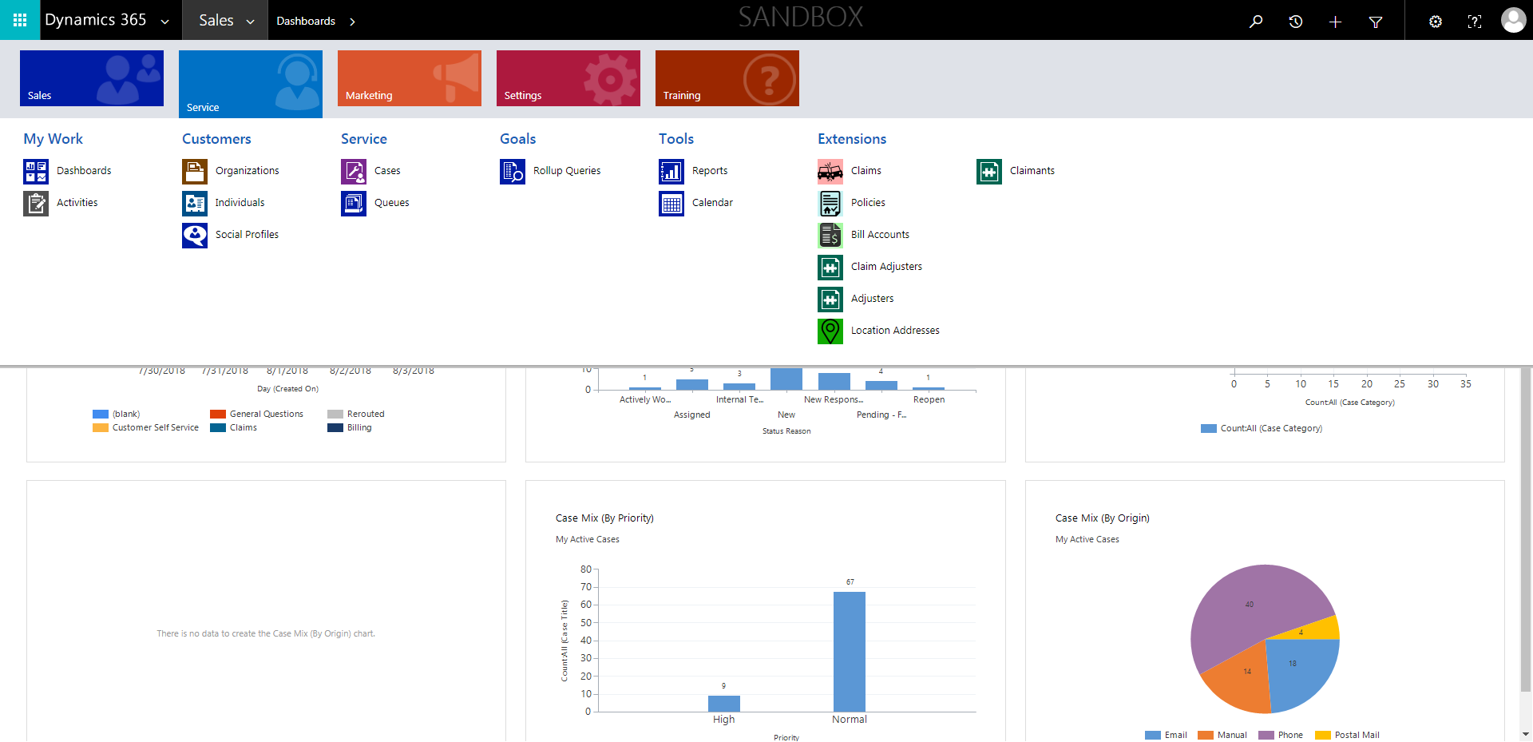

CaseManagement_CreationOfCase_Instance23_06-Aug-2018_03-28-55_AM_MouseClickActiononStaleElement.png

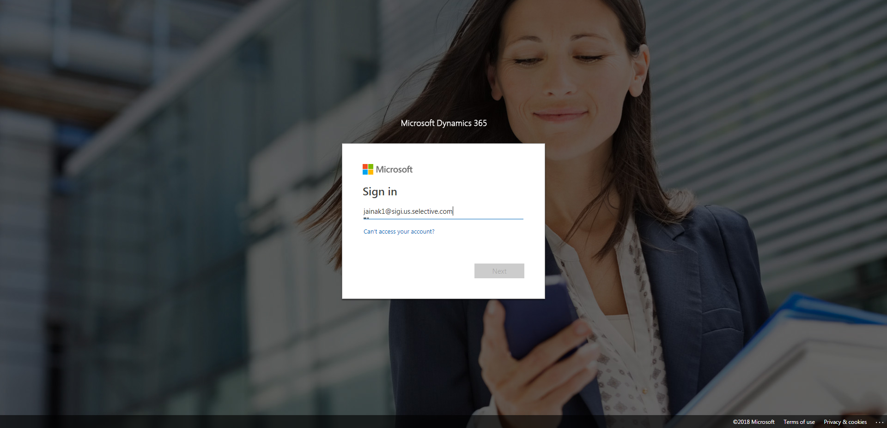

CaseManagement_CreationOfCase_Instance23_06-Aug-2018_03-29-22_AM_MouseClickActionMoveToElementBycssSelectoranavcases.png

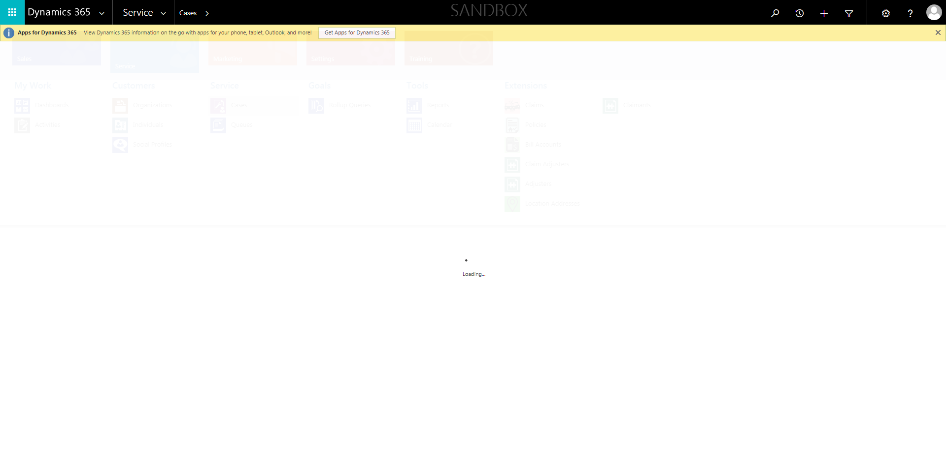

CaseManagement_CreationOfCase_Instance23_06-Aug-2018_03-29-20_AM_MouseClickActionMoveToElementBycssSelectorspanTabSFA.png

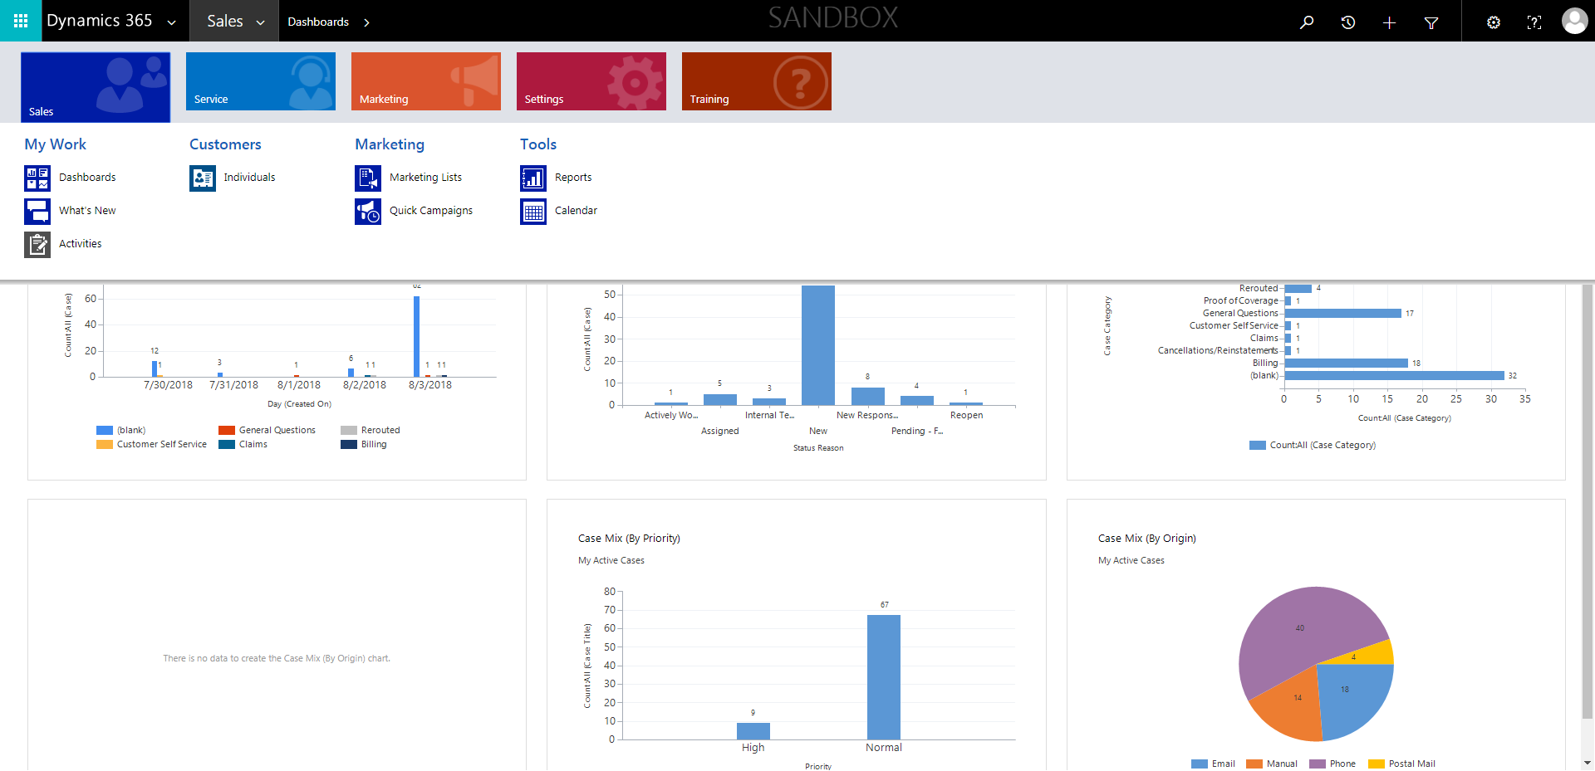

CaseManagement_CreationOfCase_Instance23_06-Aug-2018_03-28-53_AM_EnterTextAction.png

